How to create a report of successful and unsuccessful logins to Alma for a specific time period | 
Yoel Kortick
Senior Librarian

Question:
I want to see how many logins to Alma there have been for a specific time period, for example how many successful logins and unsuccessful logins to Alma were there in the past month or year?

Short Answer:
In order to make a report with number of successful and unsuccessful logins to Alma you can use the “events” subject area and filter the Event Metadata Description by “Successful login” and “The user has failed to login to the system”

Full Detailed Answer:

ONE
Create a new analysis

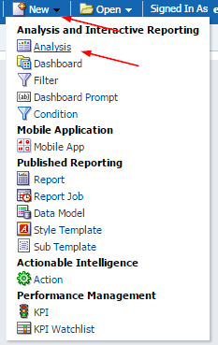

TWO
Choose subject area “events”

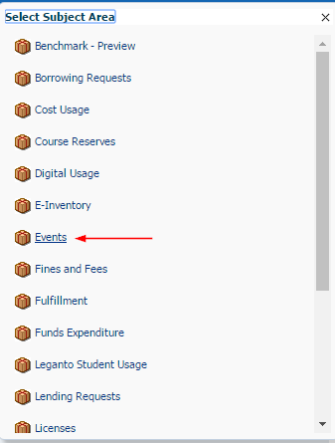

THREE

In the criteria tab left pane choose fields
- “Description” from the “Events Metadata” folder
- “Num of Events” from the “Event Keys” folder

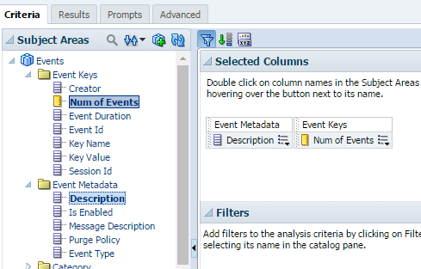

FOUR

On the filter section of the right pane click the “create a filter” icon

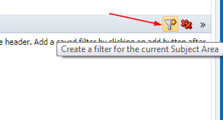

FIVE

Select “More Columns” and choose the field “”Date Key” from the “Event Date” folder

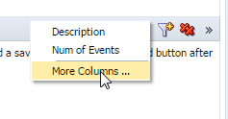
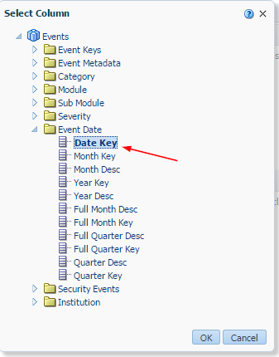

SIX

Filter by the last month (or whatever you want).

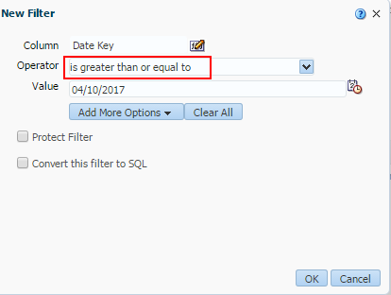

SEVEN

Instead of hard coding it by a specific date you can also have it always take the last month my converting to SQL and changing
"Event Date"."Date Key" >= date '2017-04-10'
To
"Event Date"."Date Key" >= TIMESTAMPADD(SQL_TSI_MONTH,-1,CURRENT_DATE)

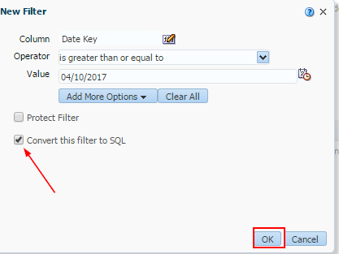

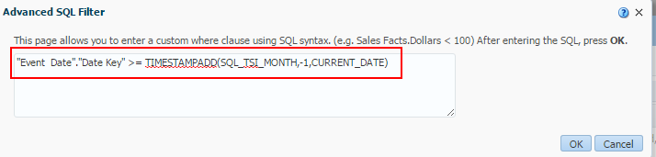

EIGHT

Filter the Event Metadata Description by “Successful login” and “The user has failed to login to the system”

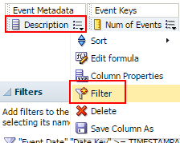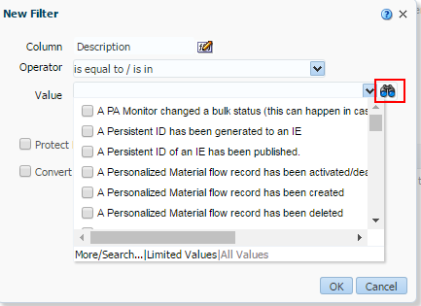

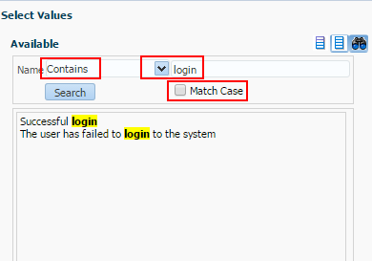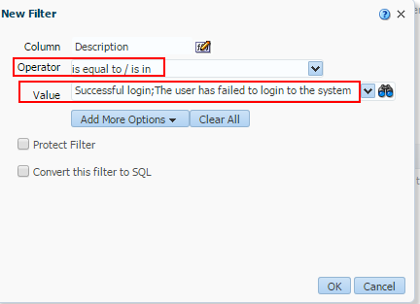

NINE

See results. For example:

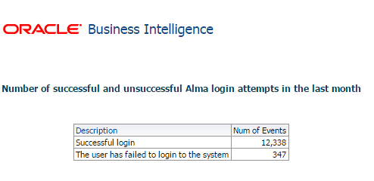

TEN

If you want to see who the user name of the staff user who logged in you can include the field “Creator” from the “Event Keys” folder. Note that in the case of “The user has failed to login to the system” the “Creator” will be registered as “System” (because no one really logged in).

